**Project Design Phase**

**Solution Architecture**

|  |  |
| --- | --- |
| Date | 28 June 2025 |
| Team ID | LTVIP2025TMID58256 |
| Project Name | Visualizing Housing Market Trends: An Analysis Of Sale Prices and Features Using Tableau |
| Maximum Marks | 4 Marks |

**Solution Architecture Diagram:**

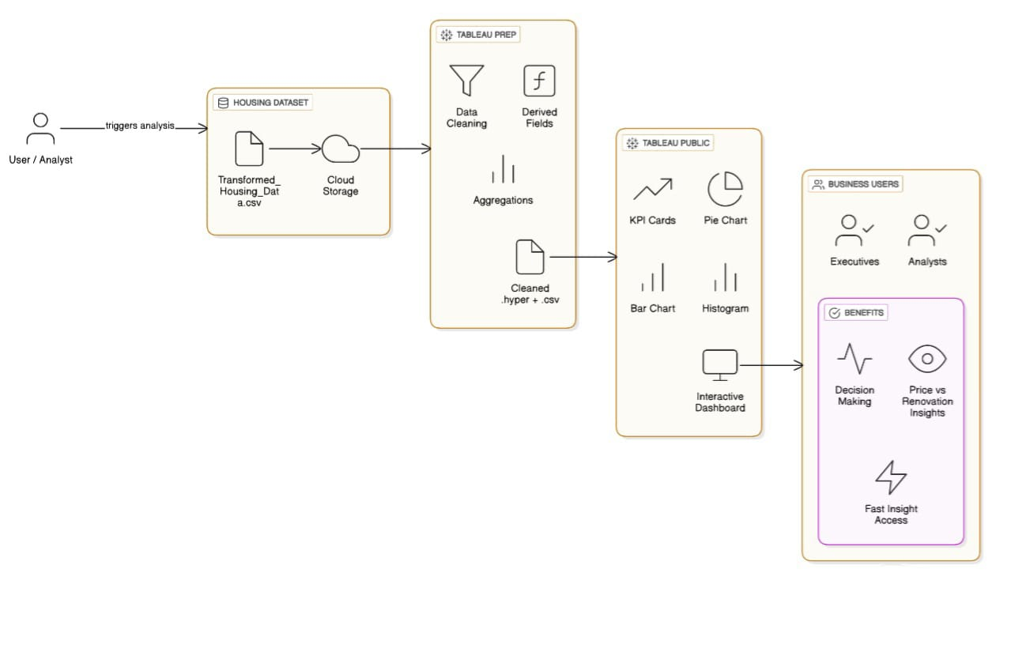 *Architecture and data flow of Visualizing Housing Market Trends: An Analysis of Sale Prices and Features Using Tableau*